Part 1

1. Noise vector size 50 Noise vector size 100

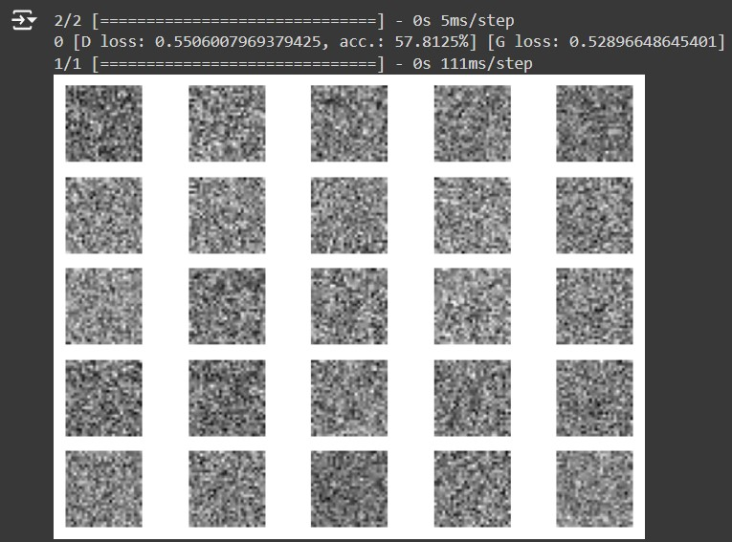 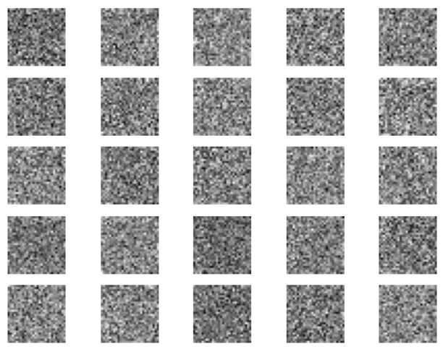



1. Three different batch sizes (32, 64, and 128) were used during GAN training, and the results showed significant differences in training performance,

**Batch Size 64**: Provided the best balance between stability and performance. The discriminator loss was 0.685, and accuracy was 60.16%, indicating a reasonably effective discriminator.

**Batch Size 32**: The discriminator had a high loss of 1.383 and very low accuracy of 9.38%, suggesting that the smaller batch size introduced too much noise into the training process, leading to instability.

**Batch Size 128**: Initially resulted in poor performance, with a high discriminator loss of 3.69 and low accuracy of 3.67%. Larger batch sizes tend to stabilize training over time, but may start off less effective due to slower updates.

Part 2

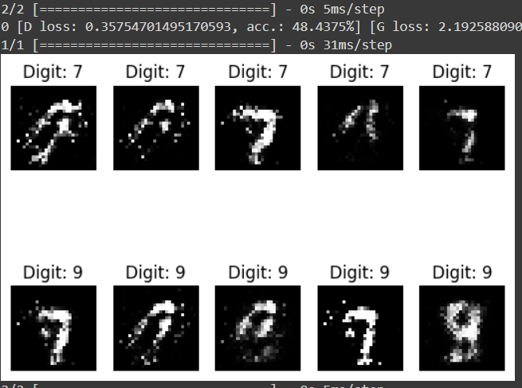

2)

Label smoothing was implemented by replacing the real labels of 1 with random values between 0.9 and 1 during training, which encouraged the discriminator to be less confident in its predictions. This technique improved the stability of the training process, allowing the GAN to converge more effectively and reducing the risk of overfitting. As a result, the generator produced higher-quality images with greater diversity. Overall, label smoothing enhanced the training dynamics, leading to a more robust model capable of generating more realistic outputs.

3)

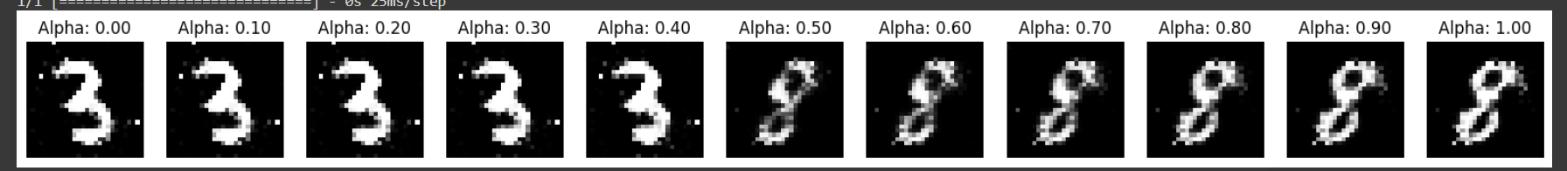

Part 3

1. Generating automobile images,

epoch_0 epoch_100 epoch_200

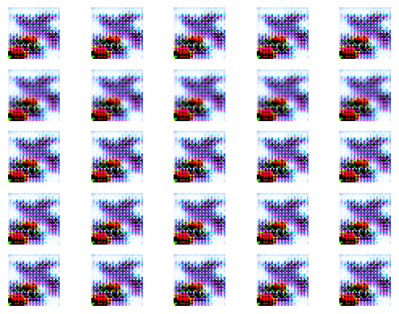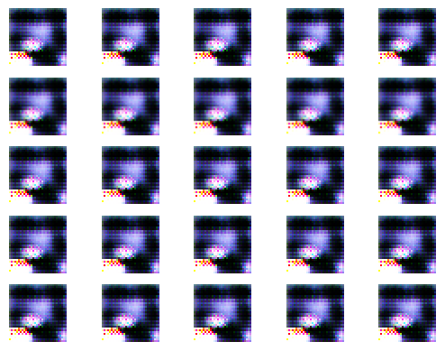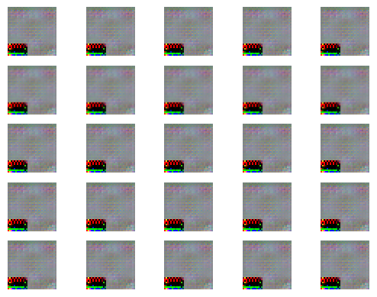

epoch_300 epoch_400 epoch_500

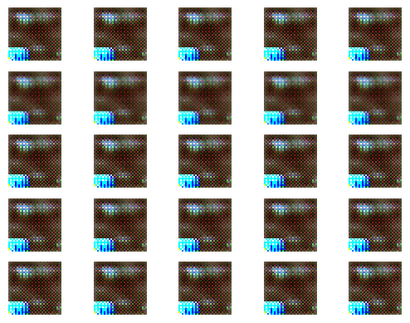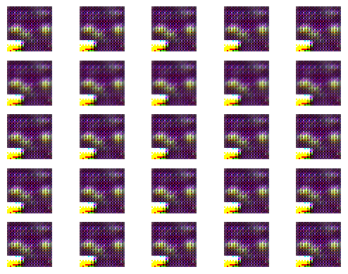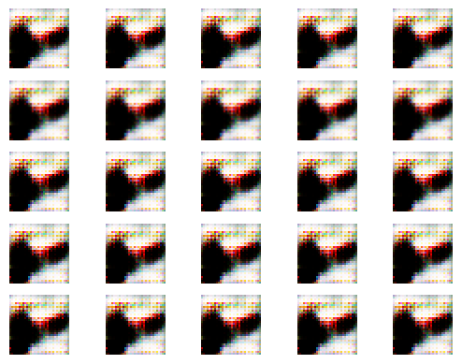

epoch_600 epoch_700 epoch_800

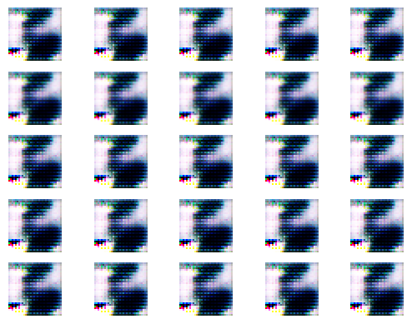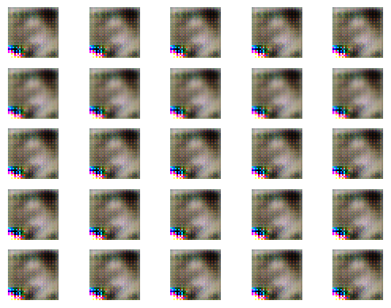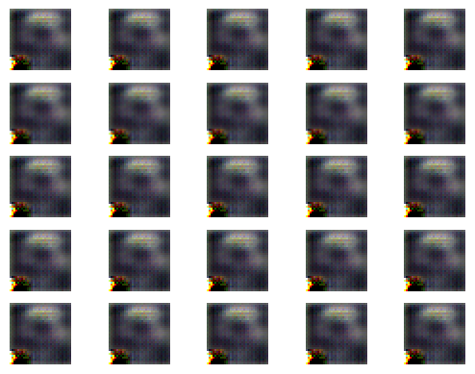

epoch_900

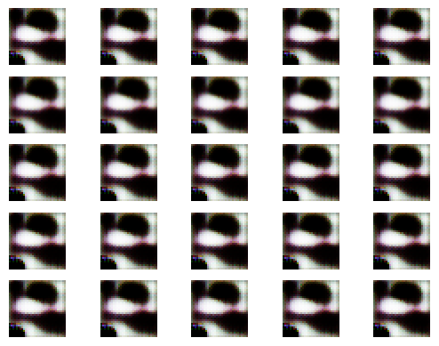

1. After augmentation

epoch_0 epoch_100 epoch_200

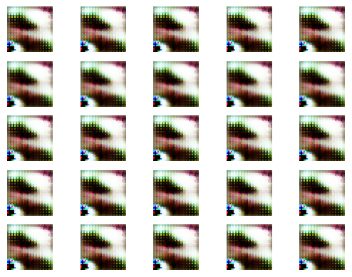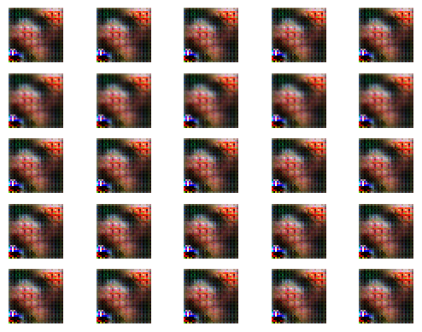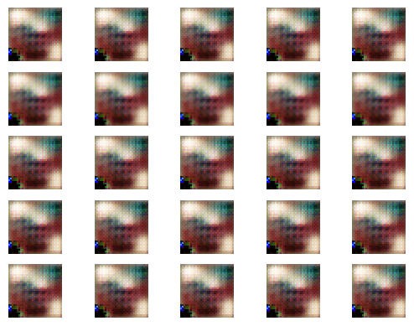

epoch_300 epoch_400 epoch_500

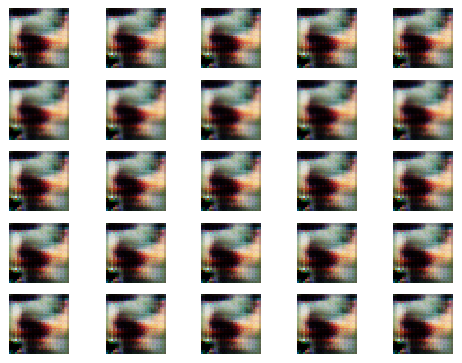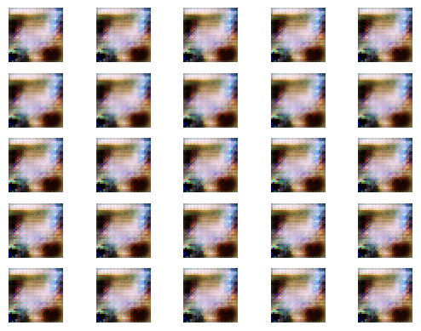

epoch_600 epoch_700 epoch_800

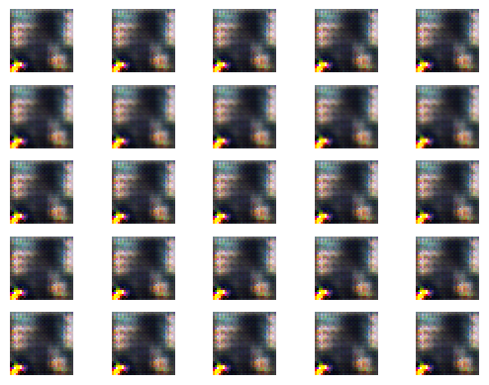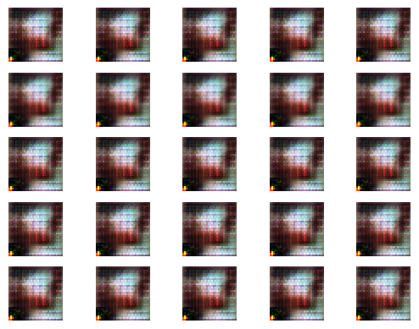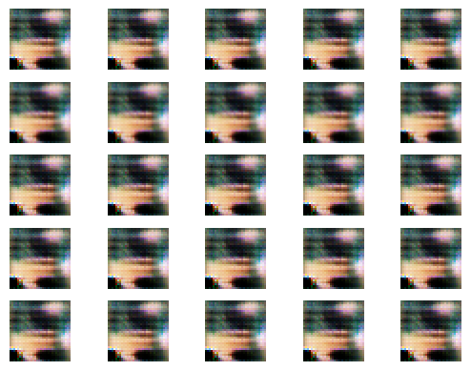

epoch_900

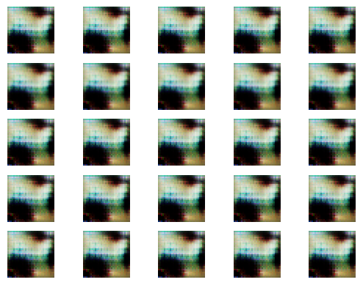

3)

Inception Score at epoch 2000: 1.0000008344650269 ± 2.77017363714549e-07

Inception Score at epoch 5000: 1.0 ± 6.529361940010858e-08

epoch_0 epoch_1000 epoch_2000

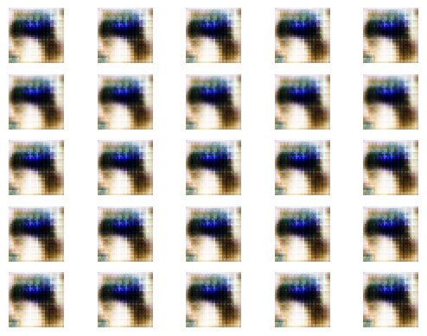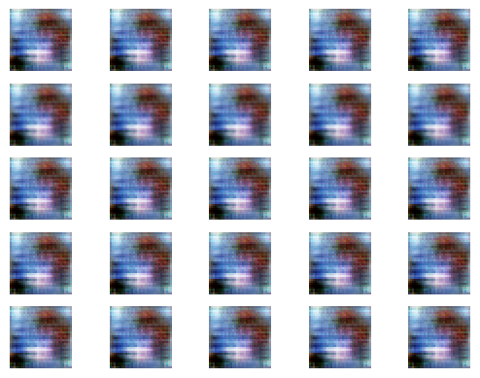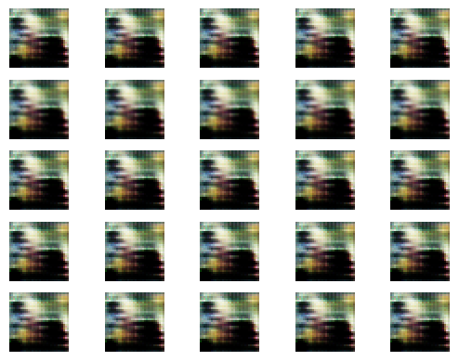

epoch_3000 epoch_4000 epoch_5000

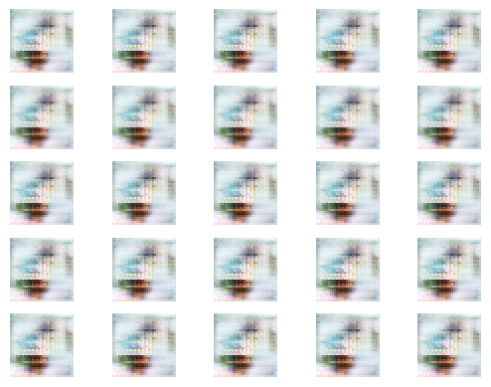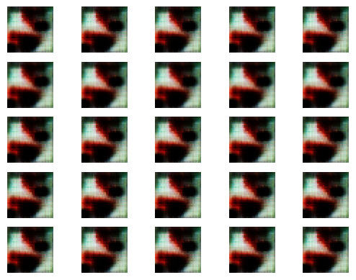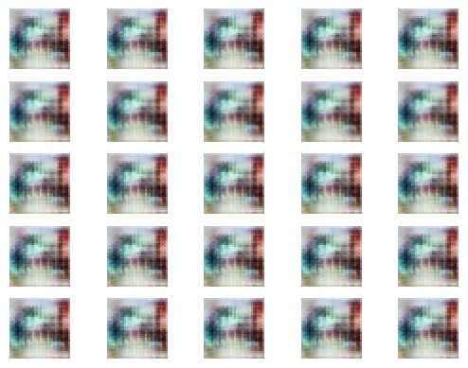

epoch_6000 epoch_7000 epoch_8000

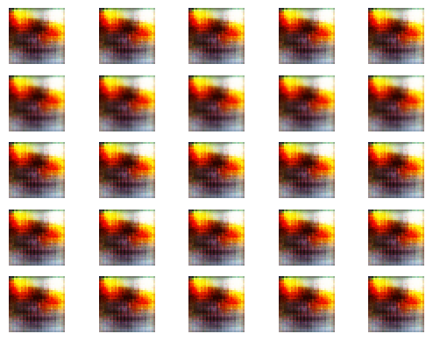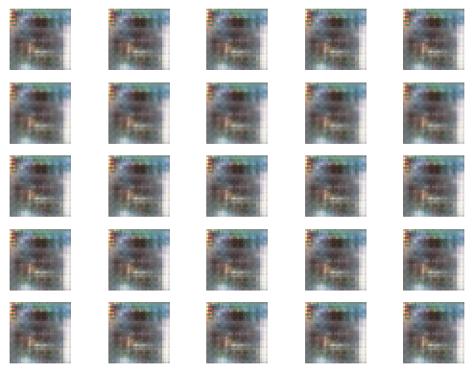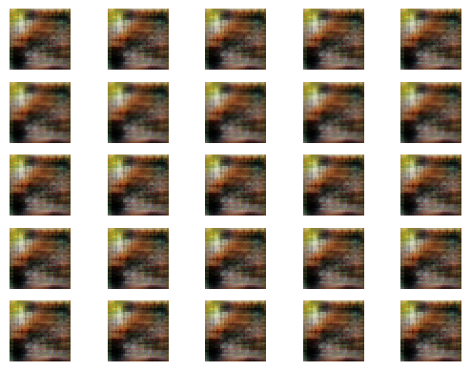

epoch_9000

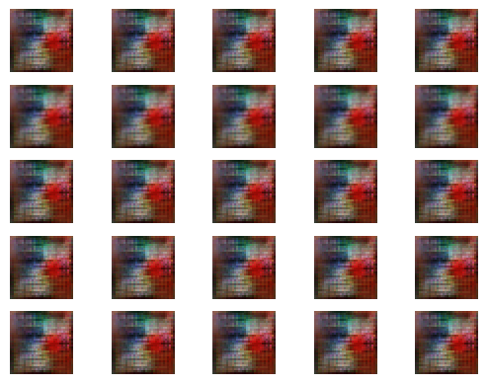

4)

**Generator**,

* **Added Layer**: One Conv2DTranspose layer with **32 filters**.

**Discriminator**,

* **Added Layers**: Two Conv2D layers with **256 filters** and **512 filters**, respectively.

epoch_0 epoch_100 epoch_200

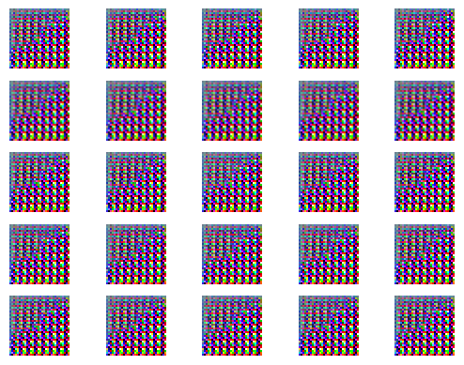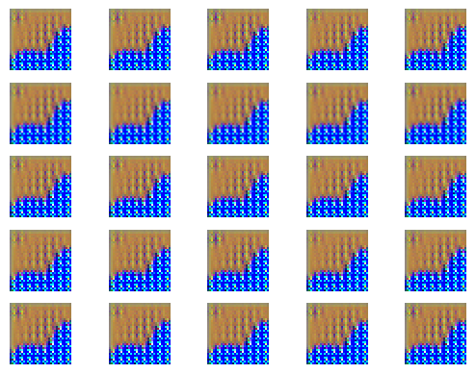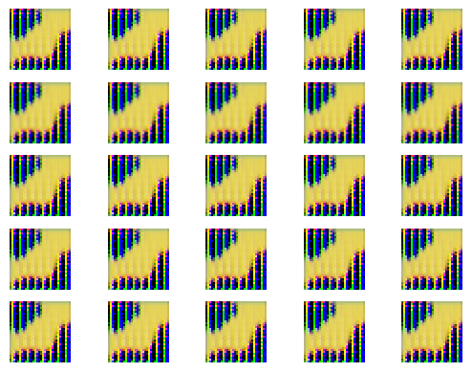

epoch_300 epoch_400 epoch_500

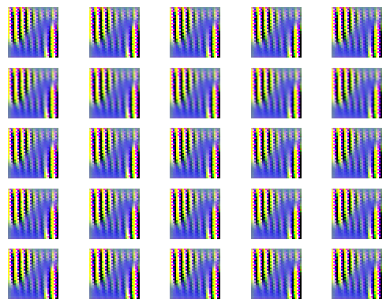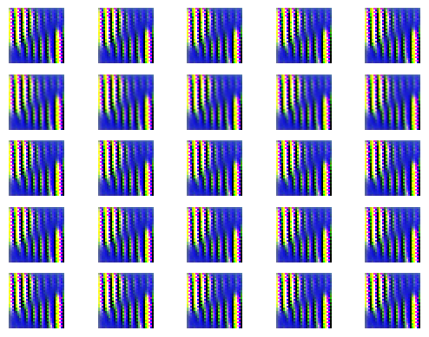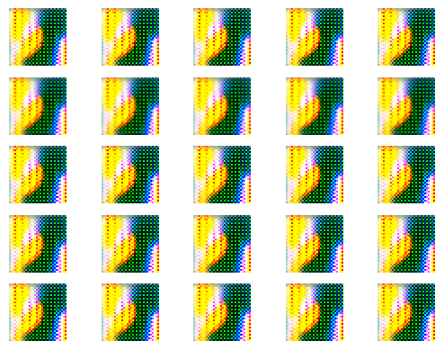

epoch_600 epoch_700 epoch_800

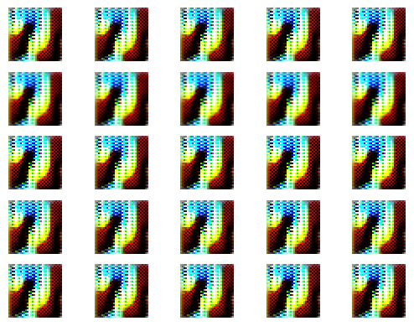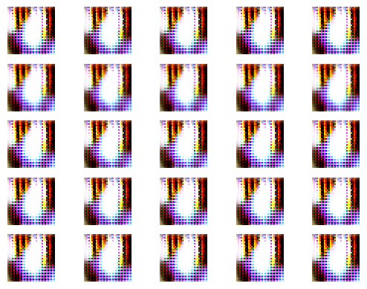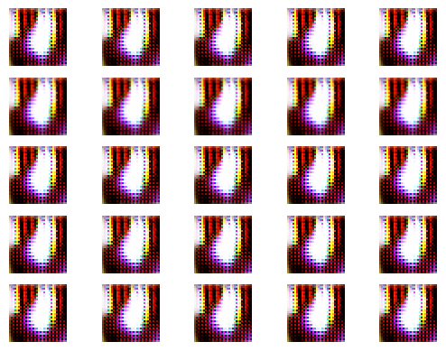

epoch_900

